SOCIAL MEDIA DASHBOARD
@CREATIVITY THINK (9483175986/7019689991)

ABSTRACT:
The Social Media Dashboard is a web-based platform designed to support interactive user communities by providing features such as posts, user feeds, direct messaging, media uploads, notifications, and analytics. This system offers role-based access for Users and Administrators. Users can create posts, send messages, connect with others, and track engagement stats, while Administrators are responsible for monitoring content, moderating users, managing reports, and broadcasting updates. Developed using Django and Django REST Framework on the backend and React with Redux and Socket.io for real-time communication on the frontend, this project delivers a modern, scalable solution suited for professional, niche, and private social networks..

INTRODUCTION OF THE PROJECT:
Modern communities and professional networks rely on digital platforms for communication, content sharing, and real-time interaction. Traditional social media systems are often complex, expensive, or feature-heavy for smaller communities or niche audiences. The Social Media Dashboard bridges this gap by offering an elegant, lightweight, and structured platform with essential social features. It enables content posting, messaging, feeds, follow/connect functionality, and analytics in an efficient and user-friendly interface. Real-time updates through Socket.io ensure instant messaging and notification delivery, providing a seamless communication experience similar to major social networks..

PROJECT OBJECTIVES:

• Provide an interactive platform for posting content and sharing updates.
• Offer a real-time messaging system using Socket.io for smooth communication.
• Enable user connections through follow/connect features.
• Deliver notifications for messages, follows, likes, and posts.
• Allow administrators to moderate posts, users, and abuse reports.
• Generate analytics and engagement statistics for users and admins.
• Create a responsive and scalable architecture suitable for multiple community types.
• Ensure secure authentication and role-based access handling.

PROBLEM OF THE STATEMENT:
Many niche communities require a digital platform for collaboration, communication, and content management, but major social networks do not offer customization, privacy, or moderation tools tailored to them. Additionally, building a social platform from scratch is often time-consuming and technically demanding. The Social Media Dashboard solves this problem by providing a tailored solution for community-centric interactions, featuring real-time messaging, content moderation, analytics, and user engagement—all packaged in a clean, responsive dashboard interface..

MOTIVATION OF THE PROJECT:
• To support private or professional communities needing their own social network.
• To enable structured content sharing, messaging, and engagement.
• To provide admins with full control over moderation and user management.
• To create a modern, scalable alternative to large social platforms.
• To ensure real-time communication without relying on third-party apps.
• To offer a unified dashboard for users and admins with analytics and insights.

BLOCK DAIGRAM OF PROJECT:

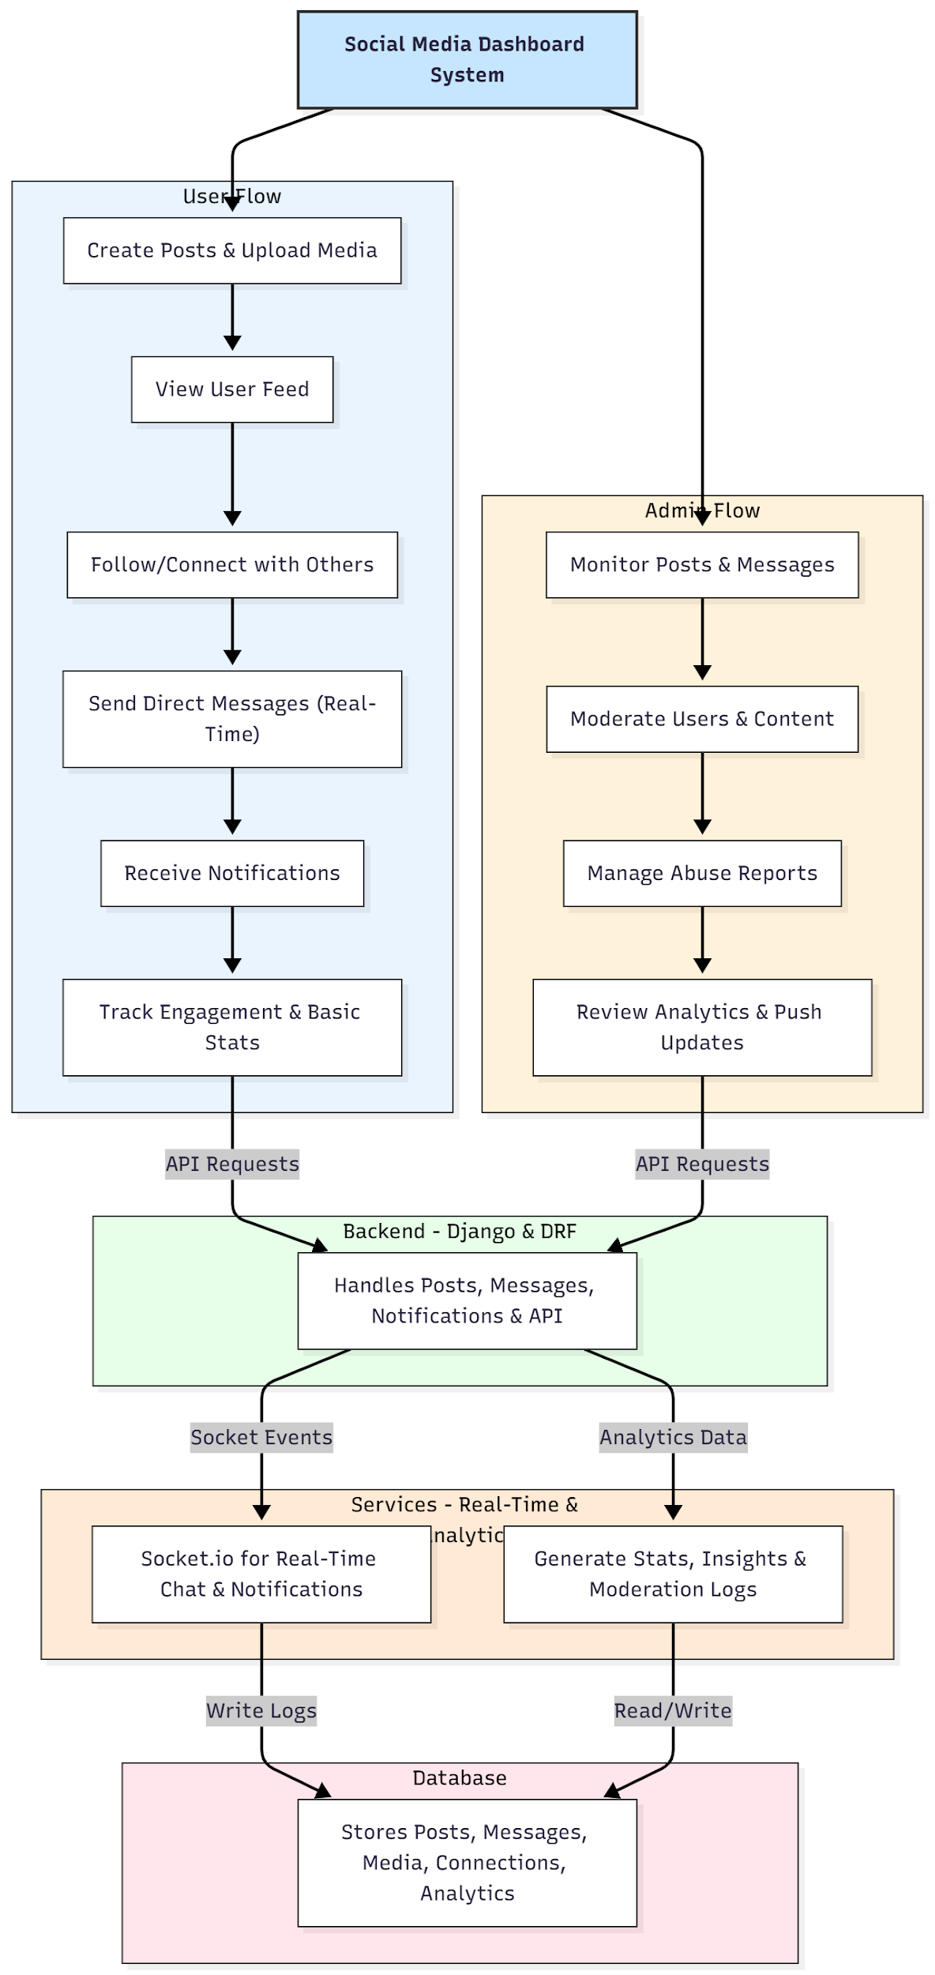

WORKING OF THE PROJECT:
Users begin by registering or logging into the platform. They can create posts, upload media, and interact with other users via likes, comments, or follows. The dashboard displays a dynamic feed based on the user’s connections. Real-time chat and notifications are powered through Socket.io, enabling instant message delivery and live alerts for follows, messages, and interactions. Administrators access a dedicated panel to moderate posts, manage user accounts, review abuse reports, and push news updates. The backend ensures secure authentication, content storage, message handling, and analytics processing. All data, including posts, media, chats, and statistics, is stored in a structured SQL database for smooth performance and reporting..

SOFTWARE REQUIREMENT:
- Backend:
  - Python 3.x
  - Django
  - Django REST Framework
  - SQLite/PostgreSQL
- Frontend:
  - Node.js and npm
  - React.js
  - Axios
- Development Tools:
  - Visual Studio Code
  - Postman (for testing APIs)
  - Git/GitHub (for version control)
- Server/Deployment (Optional):
  - Gunicorn, Nginx, or Heroku/AWS for hosting

ADVANTAGES OF THE PROJECT:

• Real-time messaging and notification system.
• Media upload and post sharing for user engagement.
• Follow/connect system improves social interaction.
• Comprehensive admin moderation tools.
• Analytics for both users and administrators.
• Scalable frontend and backend architecture.
• Secure content handling and role-based access.
• Suitable for niche communities, private groups, and organizations.

APPLICATIONS OF THE PROJECT:
• Professional networking communities
• Private organizational networks
• School/college communities
• Thematic or interest-based groups
• Internal communication platforms
• Niche social media platforms
• Private clubs and associations

REFERENCES:

- Django REST Framework Documentation — Django Software Foundation. Django Documentation. Available: https://docs.djangoproject.com/
- Django REST Framework. DRF Documentation. Available: https://www.django-rest-framework.org/
- React. React Official Documentation. Available: https://reactjs.org/docs/getting-started.html
- Redux. Redux Documentation. Available: https://redux.js.org/introduction/getting-started
- PostgreSQL Global Development Group. PostgreSQL Documentation. Available: https://www.postgresql.org/docs/
- MySQL. MySQL Reference Manual. Available: https://dev.mysql.com/doc/
- Git. Git Documentation. Available: https://git-scm.com/doc
- Node.js. Node.js Documentation. Available: https://nodejs.org/en/docs/
- Axios. Axios Documentation. Available: https://axios-http.com/docs/intro
- Socket.io Documentation – https://socket.io/docs/

